Extra Tutorial – Data Warehouse
Star Schemas and Aggregation

Here we see a fact table at the lowest level of granularity required for the Data Warehouse. Recall that this may not be the lowest level available in the source data; there may have been some aggregation when the DW was populated. This however does not concern us here.

Let us review some of the issues

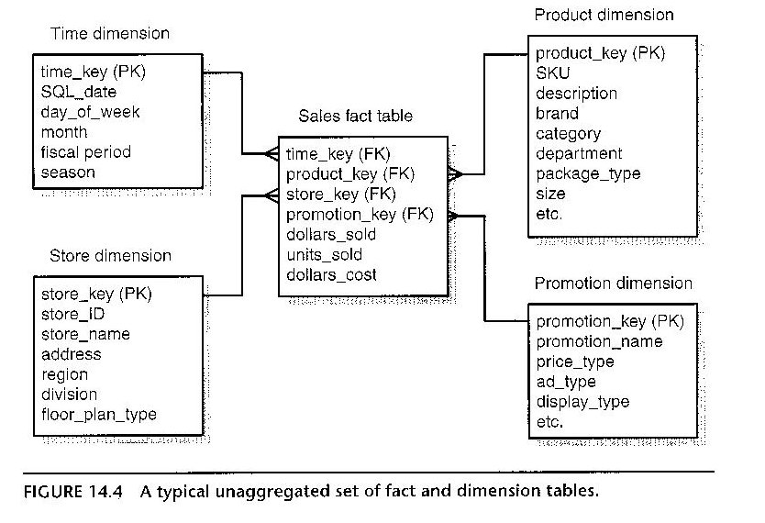
Reasons for Aggregation
- Management need to see reports of data at summarised levels
- Common summary levels
- Geographical
  - Location
  - Divisional
- Product / Product Groups
- Customer types
- Time

Design issues
- Stored in own fact tables – each aggregation gives rise to a new fact table
- Shrunken dimension tables – new dimension tables without lower level data
- Family of Schemas
  - All the aggregations give rise to their own tar schema which must be related to the original
  - There must be no loss.
- End User Transparency
- Review

DBA issues
- Performance – need many levels to improve access times
- Storage – all DW/DM demand lots of space; rule of thumb 100%
- Cardinality of values – levels of aggregation
- Common groupings – find those that can be used for more than one query
Where and how

- Outside the DW – who does this?
- Over time – data added as part of the extraction
- Part of load process
- Using (e.g.) SQL in the DW – only if good hr resource
- Packages – specifically designed.

Some possible aggregations

Which products / brands / size flavours sell in which store / regions?
Which products are bought by which customer demographic type?
What is the value of sales of each product by store each month?

Any more?

So, in what way might we want to aggregate this schema?

TASKS

Required aggregations
- Total value of each brand sold by district by quarter.
- Compare sales of widgets year on year to see the effect of the BOGOF promotion in the first quarter.

- Consider the issues and produce a schema for this aggregation
- Write the necessary materialized views (or logic / pseudo code)
- Write the necessary SQL for the creation of a dimension (or logic / pseudo code)

Further tasks
Plan data
For each table plan 5 (or more) rows of data. This will ensure you fully understand what each attribute represents and how the data links together.

Appreciate the potential data for the fact table, and identify/discuss where the ‘measure’ data will come from.
Use Excel to plan the data for the tables.

Create tables with data
Create the tables and load the data into SAS.

